SONG TITLE RIGHT JUSTIFIED
Performance tips; special instructions.

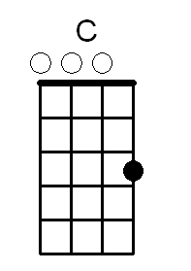
Intro = explained here.

[G] Verse #1 begins here. [C] Chord letters are located inside square [G] brackets. [C] Brackets and letters
[G] are bold, with a single space [D] outside the brackets.[G] The font is 12 pt. Arial.This is one
[D] of the easiest fonts [C] to read when songs [G] are written in this “in-line” format.

[G] Verse #2 begins here. [D] Putting chords [C] in-line with text [C] has many advantages.
[G] E.g. You can easily transpose the entire song by using [G] the “search replace” feature
[C] in your word processor. [G] This format [C] is also compact, [D] and reduces alignment errors [G] between chords & lyrics.

[G] The chorus begins here. It is indented [D] rather than italicized. [G] Leave a single line space
[C] between chorus and verses. [C] Line spacing within [G] a chorus or verse is the standard 1.15
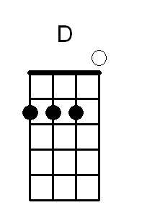
[G] Line numbers in the left margin [C] are intentional.

[G] Margins are already optimized. [D] E.g. for 3-hole punching. [C] Copy and paste [G] chord diagrams from
[D] the separate library file on our website. [G] After pasting diagrams, drag them to [D] any position.
[C] They’re already configured [G] to not disturbed existing text formatting.

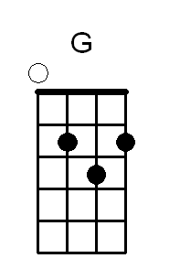
[G] Chord diagrams were created [C] using “Chord Alchemy” [C] software by Tone Alchemy.
[G] More complex chords, not found in the file [G] on our website, [D] can easily be created. Chord Alchemy
[C] exports *.bmp files [G] that can be imported into any [D] document.

[G] Portrait orientation is preferred. [C] However, some songs [C] layout better in landscape.
[G] If a song is extremely long, [C] create a second page [D] rather than decrease the font size.
[G] Allow adequate space along [D] the bottom or right side for chord diagrams.

Ending = explained here

