SONG TITLE RIGHT JUSTIFIED
Performance tips; special instructions.

Intro = D7 /// G7///. C/// 2x

[C] Oh beautiful for [G] spacious skies, for [G7] amber [F] waves of [C] grain [G]
[C] Brackets and letters [G] are bold, with a single space [D] outside the brackets.

[G] The font is 12 pt. Arial. This is one [D] of the easiest fonts
[C] to read when songs [G] are written in this “in-line” format.

[G] Verse #2 begins here. [D] Putting chords [C] in-line with text
[C] has many advantages. [G] E.g. You can easily transpose the entire song by using
[G] the “search replace” feature [C] in your word processor. [G] This format
[C] is also compact, [D] and reduces alignment errors [G] between chords & lyrics.

[G] The chorus begins here. It is indented [D] rather than italicized.
[G] Leave a single line space [C] between chorus and verses.
[C] Line spacing within [G] a chorus or verse is the standard 1.15
[G] Line numbers in the left margin [C] are intentional.

[G] Margins are already optimized. [D] E.g. for 3-hole punching.
[C] Copy and paste [G] chord diagrams from [D] the separate library file on our website.
[G] After pasting diagrams, drag them to [D] any position.
[C] They’re already configured [G] to not disturbed existing text formatting.

[G] Chord diagrams were created [C] using “Chord Alchemy”
[C] software by Tone Alchemy. [G] More complex chords, not found in the file

[G] on our website, [D] can easily be created. Chord Alchemy
[C] exports *.bmp files [G] that can be imported into any [D] document.

[G] Portrait orientation is preferred. [C] However, some songs

[C] layout better in landscape. [G] If a song is extremely long,
[C] create a second page [D] rather than decrease the font size.
[G] Allow adequate space along [D] the bottom or right side for chord diagrams.

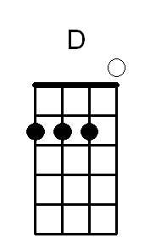
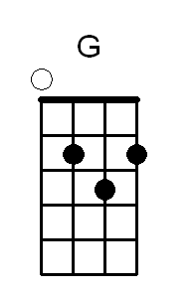
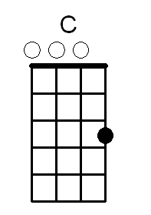
Ending = explained here

